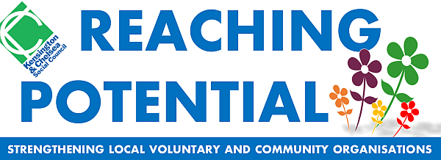
COACHING SERVICE
Thank you for expressing an interest in seeing a coach as part of our Reaching Potential programme of support for the voluntary and community sector in Kensington and Chelsea. Life/Career Development coaching can cost between £80 to £150 for a one hour session. We are therefore pleased to offer this programme of up to 4 coaching sessions for free at this current time. A key aim in providing this service is to strengthen local voluntary and community organisations by supporting the development of staff and volunteers.
As part of our evaluation of the coaching programme we will contact you after a period of time to see how the coaching is going. We would therefore welcome your co-operation in answering a few questions about your experience.
BOOKING TERMS AND CONDITIONS
Access to the coaching service
The coaching service is offered to local voluntary and community organisations. You are considered local organisations if over 50% of beneficiaries are resident in the Royal Borough of Kensington and Chelsea.
The coaching service is open to workers and volunteers from local voluntary and community organisations. Individuals cannot apply unless they can demonstrate they are working to benefit the local community.
Applications are accepted on a first come first served basis. However KCSC reserves the right to reject an application if the applicant is not considered suitable. KCSC also reserves the right to limit the number of applications from a single organisation if necessary to allow more organisations to apply. In such cases KCSC will operate a reserve list.
Bookings
Upon applying you will receive a confirmation email that your application has been received. Please retain the email as evidence.

Cancellations and failure to attend
If for any reason you are unable to attend your coaching session you must inform your coach or KCSC with at least 1 day prior notice.
Please note: You will be subject to a £50 fee if you fail to turn up to any of the sessions without a valid reason.
The service operates a 3 strike policy therefore failure to attend 3 sessions will mean the offer is withdrawn
Payments
If charged a cancellation fee payments can be made by cheque/postal order made payable to Kensington & Chelsea Social Council, via PayPal, Visa/Debit card. Organisations may also request an invoice for the payment to be made.
Your Service
If for any reason you have concerns about the service you are receiving then please contact Angela Spence at KCSC at angela@kcsc.org.uk or call 020 7243 9800.

