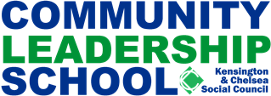
TRAINING AND EVENTS BURSARY FORM
Free places on the Community Leadership School courses, training days and other events linked to the school are available upon a completed bursary application form. Bursaries are available to organisations with an annual income of £150,000 or less. If there are any other reasons why you would like to apply for a bursary please state on the form.
To apply please complete the form and provide supporting evidence
Course name: Date:
Name:
Organisation:
Address:
Postcode:
Email:
Telephone: Mobile:

Income of organisation
Please provide a photocopy of your evidence, e.g.
- Annual accounts (annual report)
- Companies House information
- Charities commission information
- Other:
Please state any other reason why you would like to apply for a bursary

Please return your completed form to angela@kcsc.org.uk
For further information on the Community Leadership School contact Angela Spence - angela@kcsc.org.uk or call 020 7243 9802

