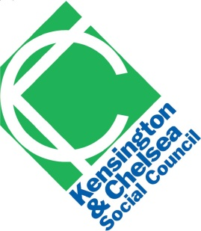 | Staff recruitment  Diversity monitoring form
Kensington & Chelsea Social Council is actively committed to promoting diversity and equality of opportunity in the recruitment and conditions of service of its staff.
This form will be separated from your job application, and we will only use this information for monitoring diversity in our organisation. This information will not be seen by the shortlisting panel.
It will not count against you if you do not wish to complete this form.

Name
Job applied for
Date
Gender
Ethnicity
Do you consider yourself to be disabled?
Where did you see the job advertised?
Do you feel that the application process has in any way put you at a disadvantage? If so, please state how.

