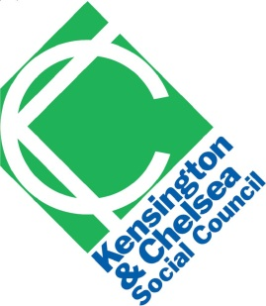 | Staff recruitment  Equality and Diversity monitoring form
Kensington & Chelsea Social Council wants to meet the aims and commitments set out in its equality policy. This includes not discriminating under the Equality Act 2010, and building an accurate picture of the make-up of the workforce in encouraging equality and diversity.
The organisation needs your help and co-operation to enable it to do this, but filling in this form is voluntary. The information you provide will stay confidential, and be stored securely and limited to only some staff in the organisation’s Human Resources section.
This form will be separated from your job application, and we will only use this information for monitoring diversity in our organisation. This information will not be seen by the shortlisting panel.
It will not count against you if you do not wish to complete this form.
Name
Job applied for
Date
Where did you see the job advertised?
Gender
Age
What is your ethnicity?
Ethnic origin is not about nationality, place of birth or citizenship. It is about the group to which you perceive you belong.
Do you consider yourself to have a disability or health condition?
What is your sexual orientation?
What is your religion or belief?

