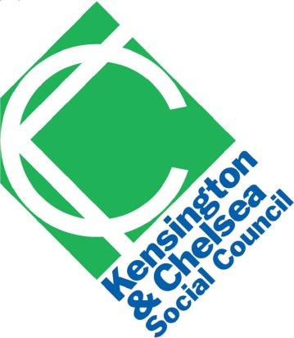 | Grenfell Tower Inquiry  KCSC Terms of Reference Submission
The Kensington and Chelsea Social Council is the local voluntary and community sector infrastructure body which counts 370 organisations amongst its active members. The organisation works to improve the quality of life for residents of the borough by supporting locally focused voluntary and community organisations (VCOs). The organisation’s main objectives are to provide:
- organisational development advice, guidance and training
- co-ordination and representation
- information and resources
- support to network and collaborate
- facilitation to develop a strong voluntary sector voice to influence decision makers

We believe in:
- Enabling voluntary and community organisations to make a difference
- Collaboration and working in partnership with others to achieve more
- A strong local voluntary and community voice
- Social justice through community action
- Being inclusive and respectful

KCSC believes the scope of the inquiry should ensure full public disclosure of all relevant central and local government information pertaining to decisions made and why they were made on:

A) The Fire
- Fire regulations since the 2010 fire at Lakanal House in Southwark
- Contractual chain of all those involved in the building works of Grenfell. This should include detailed information on the procurement and bidding process and disclosure on the decisions made and why.
- How Grenfell passed on fire regulation checks both internal and external to the building given the outcome of the fire?
- Cause of the fire, how it managed to spread so quickly and information provided to the tenants both prior to and during the fire on what they should do during a fire?
- Response to the fire
- What was the actual response of RBKC from first being notified of the fire through to the end of the first day of the fire and how far the council met with its statutory duty?
- What decisions were made following the day of the fire by RBKC on how they would carry out their statutory duty in response to the fire against what actually happened?
- The voice of the residents and other relevant parties
- What was told to the council/Cabinet Members from the residents of Grenfell and any other party on their concerns of fire safety and general health and safety issues relating to the Tower?.
- What was the council and relevant parties response to those concerns and why?
- When challenged how the council did respond and what were the reasons for the response?
- Wider considerations
  - The response of the voluntary and community sector and the residents that came together from the day of the fire. Why was there no official coordination from RBKC?
  - What is the actual council protocol in involving the voluntary and community sector in emergency situations and what can be learnt to ensure the council and the voluntary sector work effectively together in the future?
  - The culture that exists within the council particular at Cabinet level in enabling local residents to effectively and constructively challenge decisions which are felt to have a major impact on their lives. Were there channels for this to happen? If so what has worked with examples. If this is not happened why is this the case? This is particularly pertinent to matters around property, housing and regeneration within the borough.

Evidence to obtain should include:
- All relevant central government and local government information that relate to above.
- The views of all those most affected need to be heard and taken into account.
- All relevant council officers and Cabinet members involved in the decisions on the refurbishment of Grenfell Tower should provide evidence of their involvement and the decisions made, how they were made and why
- All contractors involved in the refurbishment of Grenfell Tower should provide evidence of their involvement and the decisions made, how they were made and why
- The council’s protocol for dealing with emergencies needs to be scrutinised alongside what actually took place to get a better understanding of what went wrong.

The Interim report should immediately deal with all matters relating to the fire as highlighted above in sections A and B.

The main report should contain extensive details of all questions and points raised in sections C and D above.

Please keep me informed of the work of the inquiry

Angela Spence
Chief Executive Officer
Kensington and Chelsea Social Council
angela@kcsc.org.uk
020 7243 9800

