

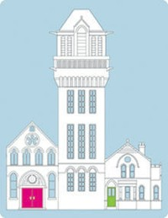

Conference Room Facilities

The St Charles’ Centre for Health and Wellbeing is located off Ladbroke Grove in North West London. St Charles’ sentinel towers have dominated this area for over a century. This beautiful grade II listed building was designed and built by the Victorian architect Henry Saxon Snell. Snell, born in 1830, had acted as assistant to Sir Joseph Paxton, the designer of the Crystal Palace of 1851. Snell specialised in hospitals and similar establishments. There had been a workhouse on the present St Charles’s site, which opened in 1792, with a capacity for 300 beds. It became one of the best run workhouse-infirmaries in London.

In 1867, the Guardians decided upon a major reconstruction. It was agreed a completely new and modern infirmary should be built. The new hospital opened in 1881 as an infirmary for the sick poor of the parish of St Marylebone.

The original building survives largely intact which is a tribute to Snell and his team of craftsmen. Snell’s magnificent construction has some interesting spaces. Some of these spaces are now available for meetings or conference facilities.

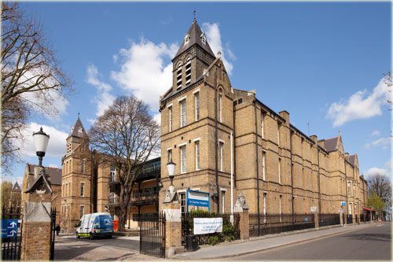



St Charles’ Conference Suites

**Conference Room 1**

This room holds up to 30 people, has conference call facilities and WIFI

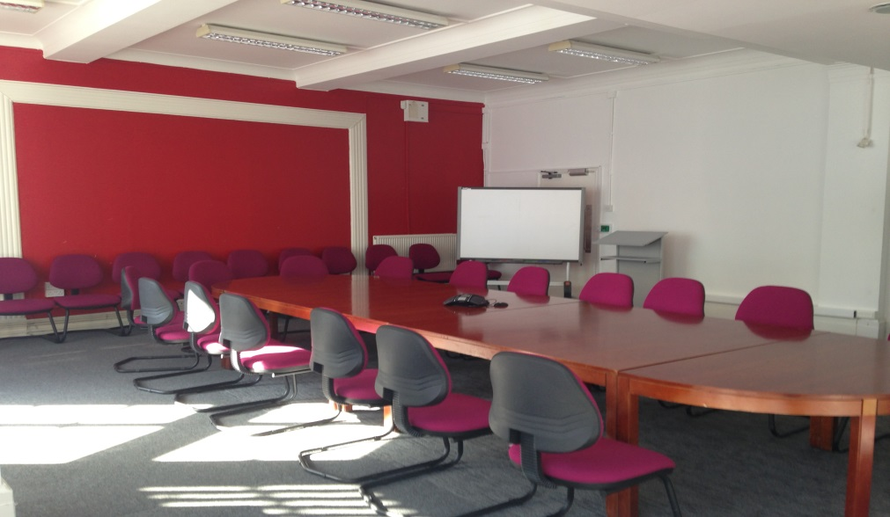

**Old Chapel**

Located above the archway entrance at the front of the centre, this atmospheric space adorned with Victorian biblical inscription will hold up to 60 people.

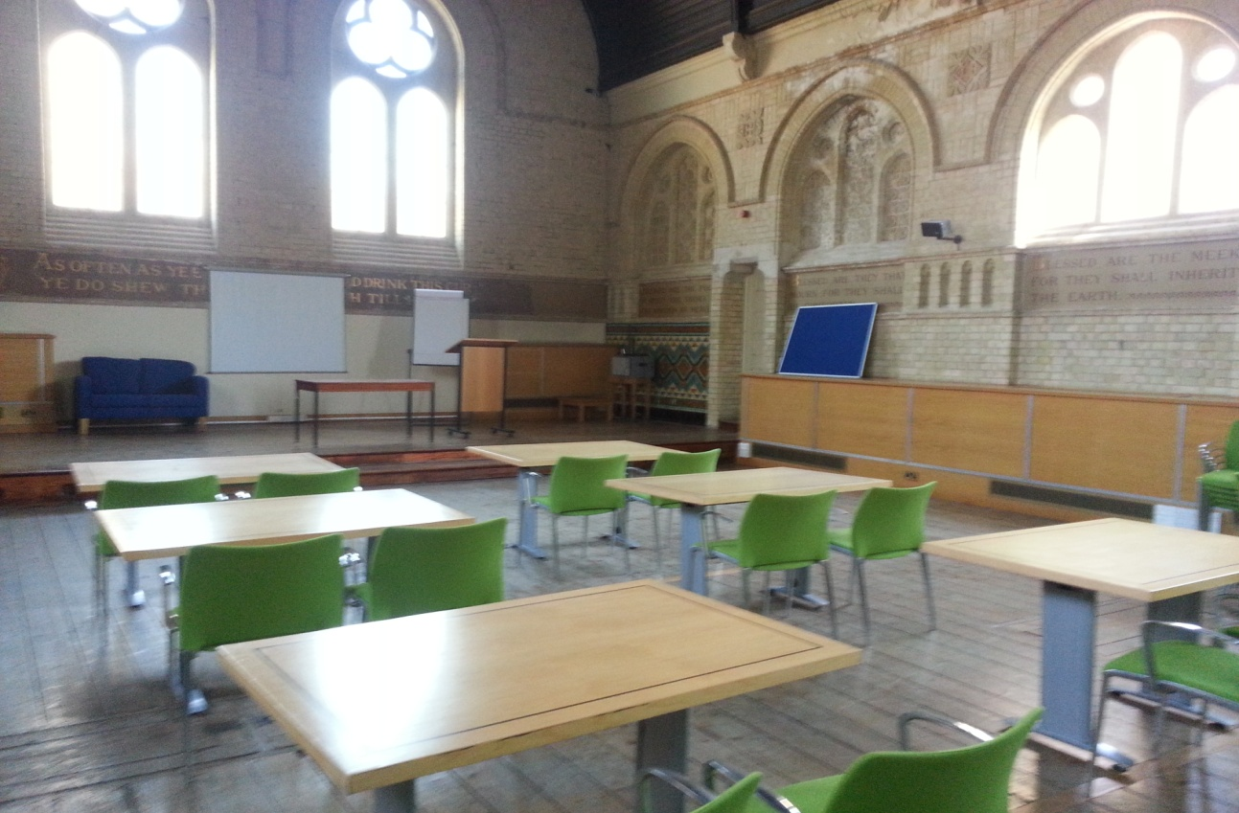

**Small Chapel**

This self-contained meeting room on the ground floor provides an intimate environment with stained glass windows and old wood panelled walls. This room holds up to 20 people.

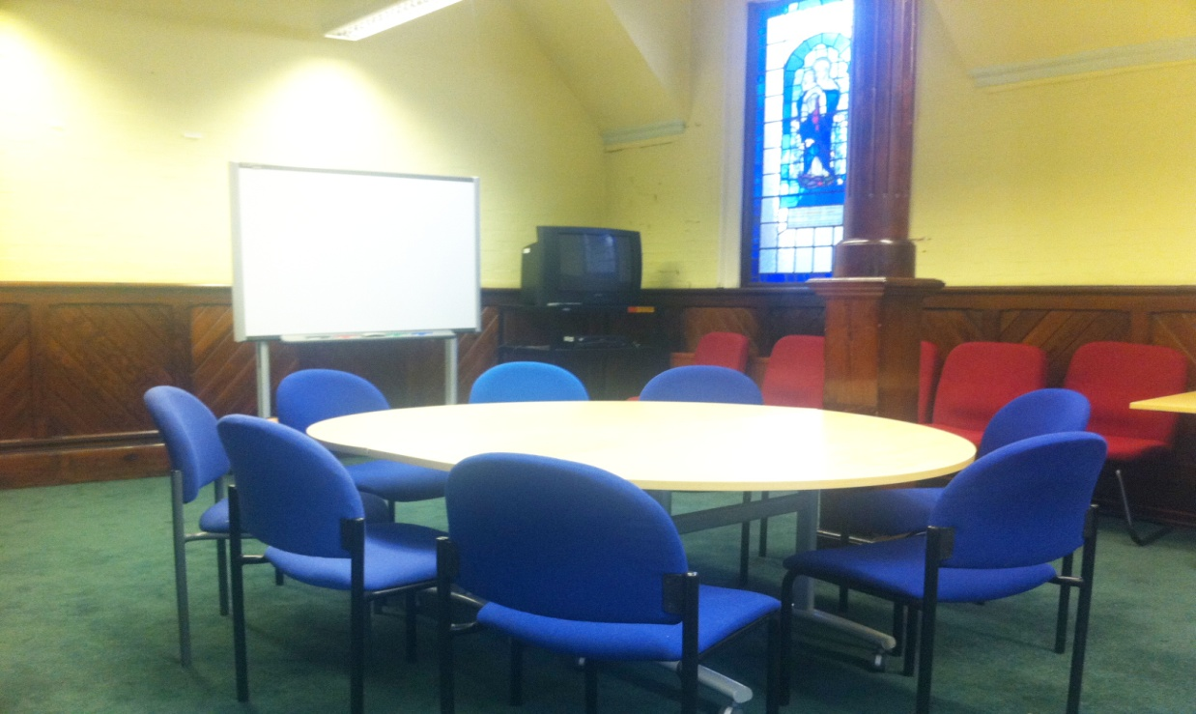

**Estates Meeting Room**

This room is located on the ground floor and holds up to 10 people. It has an interactive white board that will connect to a laptop and has conference calling facilities

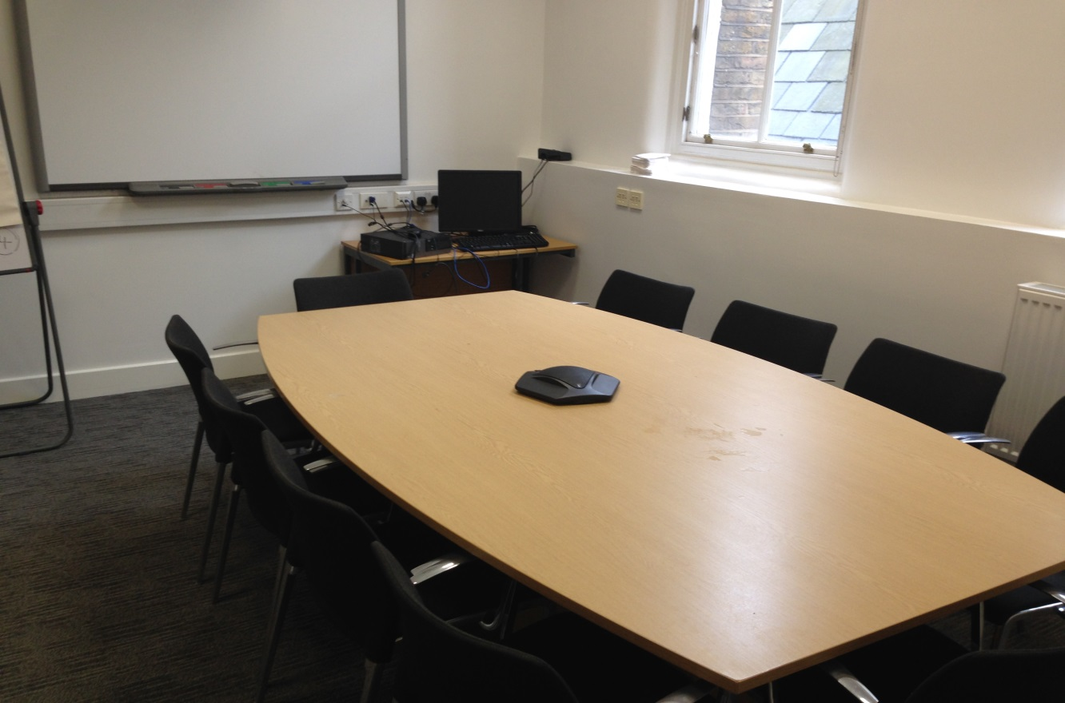**Conference Room 2**

This room holds up to 10 people, has conference call facilities and WIFI

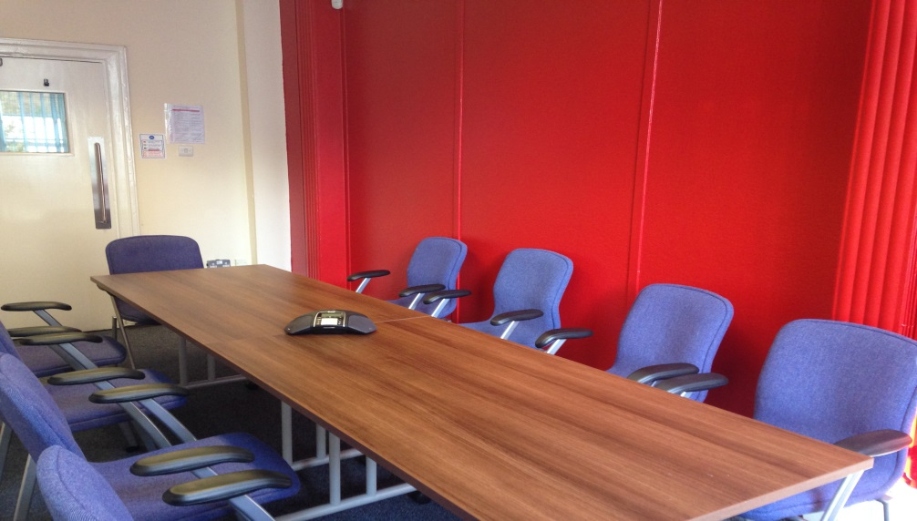

**Conference Room 3**

This room holds up to 10 people, has conference call facilities and WIFI

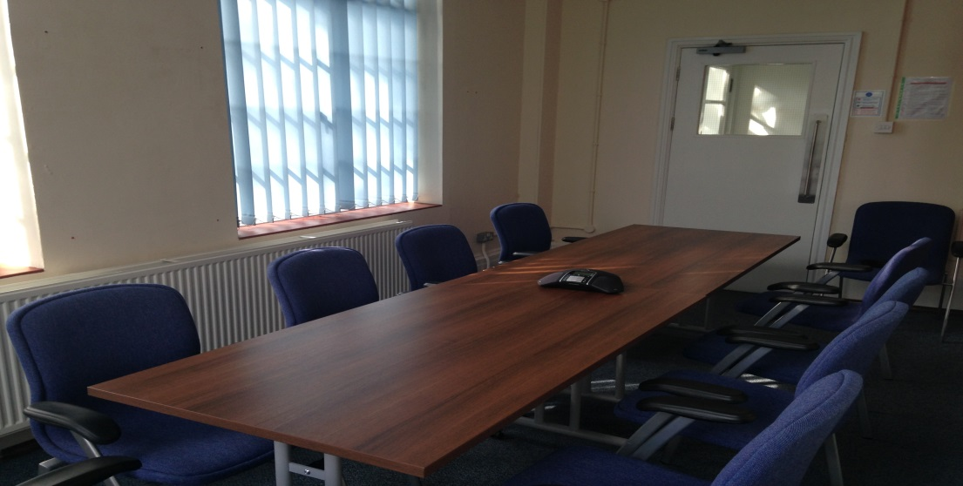

**Conference Room 4**

This meeting room holds up to 6 people and has WIFI

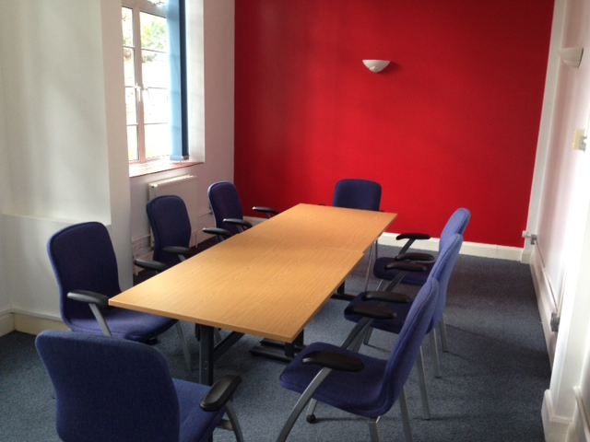

**Conference Room 5**

This meeting room holds up to 6 people and has WIFI

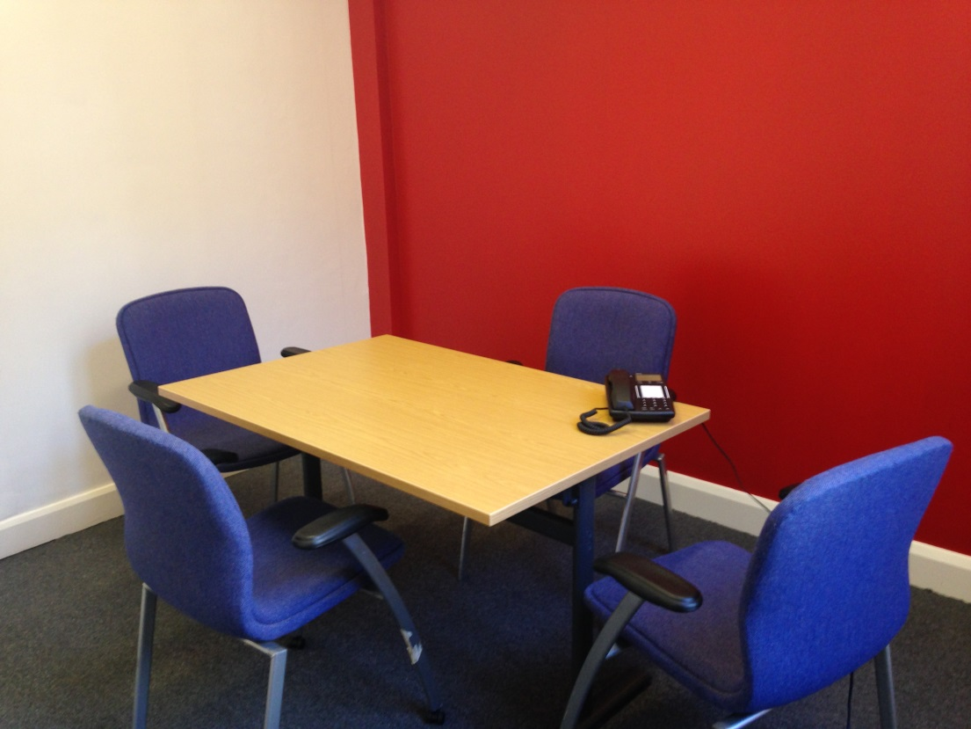

**Facilities available in our conference rooms:**

* Projector
* Laptop
* Conference Telephony
* Flipchart

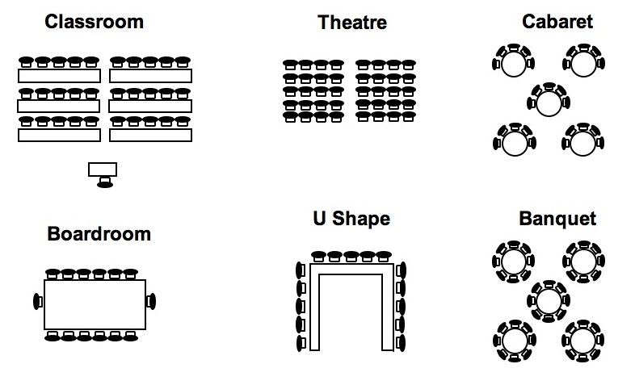

**The conference room charges are detailed in the chart below**

|  |  |  |  |  |
| --- | --- | --- | --- | --- |
| **Room** | **Delegates** | **Full-day** | **Half-day** | **Evening** |
| Conference Room 1 | 30 | 200.00 | 100.00 | 150.00 |
| Old Chapel | 60 | 200.00 | 100.00 | 150.00 |
| Small Chapel | 20 | 100.00 | 50.00 | 75.00 |
| Estates Meeting Room | 10 | 100.00 | 50.00 | 75.00 |
| Conference Room 2 &3 | 10 | 100.00 | 50.00 | 75.00 |
| Conference Room 4 & 5 | 6 | 80.00 | 40.00 | 60.00 |
|  |  |  |  |  |

Please note that the U-shape, classroom and theatre style are only available in the larger venues.

Conference rooms can be booked through the main reception desk or by calling 0208 969 2488. All prices include use of the facilities in the conference rooms, subject to availability.

Hospitality services can be provided by Accuro catering and is charged separately. Please see Accuro catering brochure for details on selection and prices. You can call Accuro on 0208 962 4098.

The contract is between NHS Property Services (NHSPS) and the customer. All bookings are subject to a written confirmation by NHSPS. Please see terms and conditions at the back of this booklet.

How to find St Charles’ Hospital



Ladbroke Grove Station



Bus Route Finder

**Day buses including 24-hour routes**

**7, 23, 52, 70, 228, 295, 316, 452**

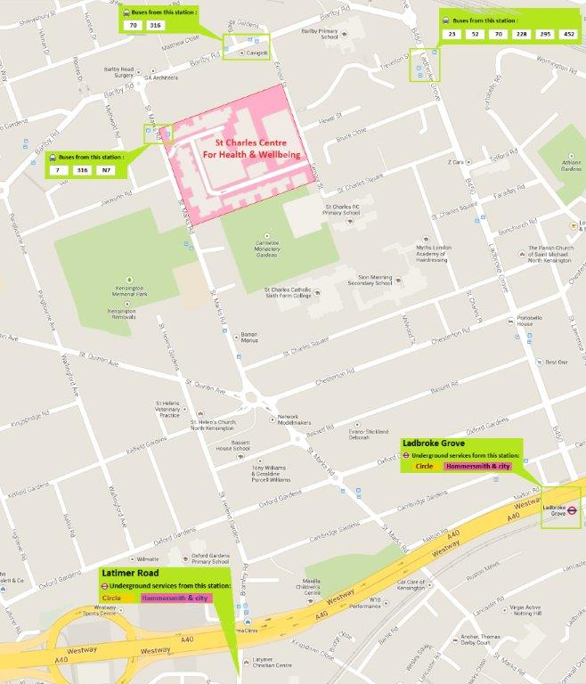

Walking from Ladbroke Grove Underground Station – Approx: 10 mins

Turn left out of the station and proceed north. Turn left onto St Charles Square and turn right into Exmoor Street. Turn left through the entrance gates and turn right through the archway and reception is located directly ahead.

Contact us

St Charles’ Hospital,

Exmoor Street,

W10 6DZ

London

**TEL: 0208 969 2488**



**Conference Rooms - Booking Terms and Conditions**

All bookings are subject to written confirmation by NHS Property Services and are subject also to the following terms and conditions:

**Importance of the booking Confirmation form:**

All bookings will be regarded as firm and a contractual relationship having been created when NHSPS receives a completed and signed booking confirmation form. Reservations will be regarded as provisional until the booking confirmation form has been received. Up until that point, NHSPS will be free to accept firm bookings from other clients for facilities, which are subject of provisional reservation.

**Charges:**

The price of the facilities and service will be stated to the customer at time of booking. The price will either be a fixed charge or a charge subject to increase, taking into account any extra costs for providing additional facilities and services.

**Confirmation of final details:**

Client organisations are required to confirm final numbers, including names of those attending and all other arrangements 7 days prior to the event-taking place. Charges will be based on this figure.

**Cancellation or alteration:**

All notifications of cancellations, any changes in the number of delegates or any change in the duration of the booking will only be deemed to be accepted when received in writing. Cancellations are subject to the following sliding scale of charges:

**Less than 1 week in advance of the first day: 100%**

**Between 1-2 weeks in advance of the first day: 50%**

**Responsibility for damage:**

The client organisation will be responsible for conference the cost of repair or replacement of the conference room property that arises from carelessness, neglect or default of any of its delegates, guests or visitors. Where it is believed such attribute damage has occurred, the Office Manager will contact the client organisation as quickly as possible.

**Unexpected closure:**

NHSPS reserves the right to cancel any booking without liability on its part, in the event of any damage or disruption to the NHSPS Offices caused by fire, flood, power failure, industrial action, act of god, weather conditions or any cause beyond our control. In these circumstances the NHS PS Office will use its best endeavours to assist the client.

**Settlement terms:**  
Payment of the client’s organisation’s final invoice is due for settlement within 30 days from the date of issue

**CONFERENCE ROOM - BOOKING FORM**

Organisation: ________________________________________________________

Contact Person:____________________ Department:_____________________

Invoice Address:_____________________________________________________

Account Code: ____________________ Cost Code: ________________________

Telephone No:___________________ E-mail:____________________________

|  |  |  |  |  |
| --- | --- | --- | --- | --- |
| **Room** | **Time** | **Full-day** | **Half-day** | **Evening** |
| Conference Room 1 |  |  |  |  |
| Conference Room 2 |  |  |  |  |
| Conference Room 3 |  |  |  |  |
| Conference Room 4 |  |  |  |  |
| Meeting Room 2 &3 |  |  |  |  |
| Meeting Room 4 & 5 |  |  |  |  |
|  |  |  |  |  |

Name of Meeting/Event:__________________________________________________

Date Room Required:___________________________________________________

No of People attending: __________________________________________________

**Equipment Required:**

Please enter number of items required.

Laptop:______ Projector:_____ Flipcharts:______

If you require hospitality please contact Accuro Catering on 0208 962 5579 or email [kandc@accuro-catering.co.uk](mailto:kandc@accuro-catering.co.uk). See hospitality sheet for details.

Please tick here to confirm acceptance of terms & conditions

Please return the completed form and payment to:

Room Bookings, Facilities department, Estates & Facilities Shared Service, Property Services, Ist Floor, The Tower, St Charles Centre for Health & Wellbeing, London W10 6DZ

Cheques should be made payable to: **NHS** **Property Services Ltd.**



**Hospitality Request Form**

(Service available from 8am to 5pm, Monday to Friday)

**Notice Required:**

Tea, Coffee, Biscuits – 24hrs

Sandwich Lunch – 48hrs

Full Buffet – 72 Hrs

Minimum Order £15

Today’s Date: Date of Function

Meeting Start Time: Number of Persons:

Meeting End Time: Venue:

Requirement:

Department and Trust: Time Request Delivery:

Organisers Name:

Contact Number

Cost Centre:

Expenses Code:

Please Fax Back to 0208 962 5579 or email kandc@accuro-catering.co.uk