Date: Friday 27th September
Venue: Great Hall, Kensington
Town Hall, Hornton Street, London, W8 7NX
Please complete and return all nomination forms to RBKC Sports Development Team by 5pm on Thursday 1st August to:
sportandleisure@rbkc.gov.uk or by post to:
Leisure Services
The Royal Borough of Kensington and
Chelsea
Pembroke Road Annexe, 37 Pembroke Road,
W8 6PW
Please complete page two of the nomination form and state why you believe the individual/group should receive an award. Please ensure you explain how the nominee meets the criteria detailed in the award category description. The maximum word limit for the citation is 300 words.
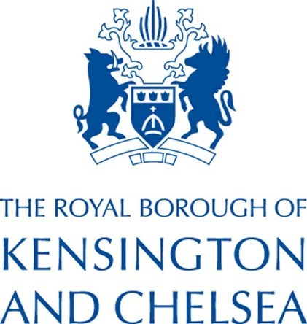
Name of Nominee:

Home Address of Nominee:

Postcode:

Telephone Number:

Email address:
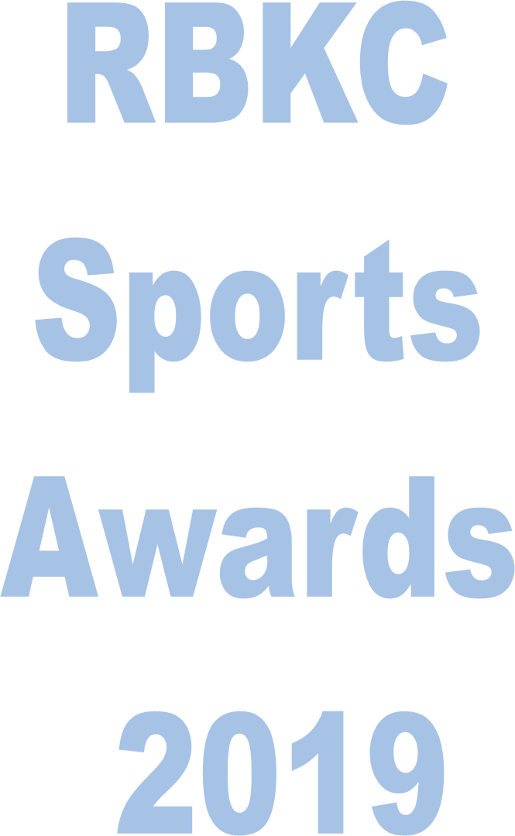
Gender:

Date of Birth: (DD/MM/YYYY)
/ /
Sport or Activity of Nominee:

Club/Sport/Association:

Parent/Guardian name:

Parent/Guardian contact details:

Name of Nominator:

Home Address of Nominator:

Postcode:

Telephone Number:

Email address:

Nominator’s relationship to Nominee
(eg Club Secretary/Coach/Manager):

- Young person’s Award | - Community Partner | - Volunteer of the Year
- Community engagement project | - Disability Sports Person | - Sport’s Organisation
-Sport’s Personality | - Power of Sport | - Outstanding Contribution
Please state why you believe the individual/group should receive this award. Please give as much detail as possible and ensure that your description matches the category to help the judges make their decision. Please note that the word count for your nomination is 300 words.
The Categories:
Name of Category: _____________________________________________________
Name of Nominee: _____________________________________________________

Please complete both sides of the nomination form and return to the RBKC Sports Development Team by 5pm on Thursday 1st August to:
sportandleisure@rbkc.gov.uk
or send to: Leisure Services
The Royal Borough of Kensington and Chelsea
Pembroke Road Annexe, 37 Pembroke Road, W8 6PW
Tweet us @rbkc_sportsteam with ‘I’ve nominated in the #rbkcsportsawards’ to share your involvement!

